Swinburne University of Technology

COS30045-Data Visualisation

Spring 2024

Topic: Global issue - Migration

Japanese Migration Analysis Process Book

Team member:

Ho Thanh An

Dang Nam Khanh

Word Count:

Due Date:

Github repository:

# Table of Content

# 

**Table of Content 2**

**1. Introduction 3**

a. Background and motivation 3

b. Visualization purpose 3

c. Project Schedule 4

**2. Data 5**

a. Data Source 5

b. Data Processing 8

i. Table 1 8

ii. Table 2 9

iii. Table 3 10

**3. Requirements 10**

a. Must have requirement 10

b. Optional requirement 11

**4. Visualization design 11**

a. Color 11

b. Visualization elements 12

**5. Validation 15**

**6. Conclusion 15**

**Reference 15**

# 

# Introduction

## Background and motivation

This visualization of migration patterns in Japan is designed to cater to a wide range of users, including policymakers, researchers, humanitarian organizations, journalists, and the general public. Policymakers seek insights into migration trends to formulate effective immigration policies and address labor shortages, while researchers aim to analyze demographic shifts and the integration of migrants into Japanese society. Humanitarian organizations require data on migrant populations to identify vulnerable groups and advocate for their rights, while journalists use such visualizations to contextualize their reporting on migration issues. The general public is interested in understanding the diverse migrant communities in Japan and their contributions to the economy and culture.

Understanding migration patterns in Japan is crucial for addressing economic, social, and demographic challenges. Migration significantly impacts labour markets, economic growth, and social cohesion, making it essential for policymakers to formulate evidence-based policies. Additionally, as Japan faces demographic shifts such as an ageing population and declining birth rates, migration is vital for sustaining workforce levels and supporting economic development. Ensuring the rights and well-being of migrants is fundamental for upholding human rights standards and fostering social justice in Japan. Therefore, this visualization plays a pivotal role in informing decision-making, fostering public discourse, and promoting a deeper understanding of migration dynamics in Japan.

## Visualization purpose

Users can investigate a range of issues related to migration in Japan using this interactive visualization. It provides important insights about the nation's migration trends and their ramifications. In order to understand the variables influencing migration to and from Japan, users can explore trends in migration volumes, sources, and destinations across time. Furthermore, the visual aid facilitates a more comprehensive comprehension of the makeup of migrant communities in Japan by enabling users to explore the demographic attributes of migrants, including age, gender, educational attainment, and work status.

When the visualization is finished, policymakers will have a vital tool for making well-informed decisions that will enable them to create labor market reforms and immigration policies supported by data. Comprehensive data analysis helps researchers spot trends that need more research and add to the scholarly conversation on migration studies. Additionally, by raising public awareness and fostering empathy for immigrant populations, the visualization empowers journalists, advocacy groups, and the general public to have meaningful conversations and support inclusive policies and activities in Japan.

## Project Schedule

Japanese migration is a relatively hard project so in order to catch up, we have to come up with a schedule that is suitable for both members:

* Week 1:
* The team gathered for the first meeting to introduce themselves and form the project team.
* Team members discussed and agreed upon team agreements and codes of conduct to ensure smooth collaboration throughout the project.
* Roles and responsibilities were assigned to each team member based on their skills and interests.
* Week 2:
* Review of team agreements and codes of conduct.
* Confirmation of assigned roles and responsibilities.
* Discussion on next steps and project timeline.
* The team reconvened to review and finalize the team agreements and codes of conduct established in the previous meeting.
* Roles and responsibilities assigned in the previous meeting were confirmed, and any necessary adjustments were made.
* The team discussed the project timeline and identified key milestones for the upcoming weeks.
* Week 3:
* Create GitHub repository:<https://github.com/Chinatsu28/COS30045-Data-Visualisation>
* Review project requirement
* Review project criteria
* Create Discord server for team collaboration
* Review some simple D3 template for visualizing data
* Plan milestones and identify tasks
* Week 4:
* Identify project idea
* Finding related dataset
* Set up template for Project Process Book
* Week 5:
* Defining project requirements and content.
* Gathering relevant resources such as datasets, documents, and references.
* The team focused on defining the specific requirements and content for the project based on the established criteria and objectives.
* Efforts were made to gather relevant resources, including datasets, documents, and references, to support the project's development and implementation.
* Weeks 6 - 8:
* Finalizing dataset and topic documents.
* Creating web views without visualization elements.
* The team worked on finalizing the selected dataset and topic documents to ensure alignment with the project requirements.
* Web views were created without visualization elements, focusing on the layout and structure of the project interface.
* Weeks 9 - 10:
* Conducting visualization coding sessions.
* Integrating charts into web views with explanations.
* Consulting the lecturer for project improvement.
* The team conducted coding sessions focused on visualizing the data using appropriate charting libraries and techniques.
* Efforts were made to integrate the generated charts into the web views, providing clear explanations and context for each visualization.
* The team consulted the lecturer for feedback and suggestions to enhance the project's quality and effectiveness.
* Week 11:
* Fine-Tuning for Perfection: Finalizing Project Elements
* Precision in Practice: Error Checking and Testing Phase
* Crossing the T’s and Dotting the I's: Project Finalization
* Week 12:
* Spotlight Ready: Preparing for Project Presentation
* Documenting Success: Submission of Project-Related Materials
* Last Mile Sprint: Ensuring Presentation Readiness

For more information about the deadline of each task included in the schedule, please check out this link to [Google Sheet](https://docs.google.com/spreadsheets/d/1EH04mUh2xh8Si_MPoRMBPLnXGiPi4t09ZClyeCmWFVI/edit?usp=sharing).

# Data

## Data Source

A significant portion of the project's data came from the [organization for economic co-operation and development](https://www.oecd.org/), [Japanese Government Statistic](https://www.e-stat.go.jp/en) and many more. This agency releases extensive reports every year that contain information on a variety of topics related to migration in multiple nations including Japan, including naturalizations, applications for visas, resident statuses, petitions for asylum and refugee status, and immigration enforcement actions. This extensive dataset served as the cornerstone for developing a sophisticated knowledge of migration trends and their effects in Japan.

Our aim was to enhance the understanding of this complex problem by employing a methodical approach to gathering and evaluating data. Through the application of this methodology, our objective was to unearth trustworthy findings and promote well-informed conversations around migration in Japan. This project played a key role in illuminating the intricate dynamics of migration inside the nation, supporting evidence-based policies and public conversation.

Dataset:

* [Organization for economic co-operation and development international migration database from 2000 to 2021](https://stats.oecd.org/Index.aspx?DataSetCode=MIG)

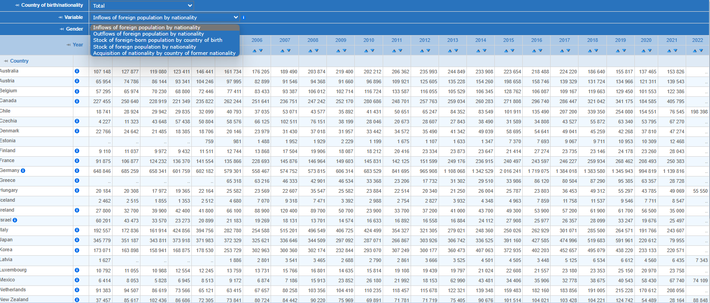

Figure 1: Inflows and Outflows of foreign population by nationality

Data on the number of foreign residents entering different nations by nationality is shown in this table. It contains data on the overall number of migrants for each year between 2000 and 2022, broken down by gender. The table shows a spectrum of countries, from Turkey and the United States to Australia and Austria. The data provides insights into historical migration trends by illustrating variations in the number of migrants from various countries over time.

* [Number of Intra-prefectural Migrants, In-migrants from Other Prefectures and Out-migrants to Other Prefectures by Sex for Japan](https://www.e-stat.go.jp/en/dbview?sid=0003420473)

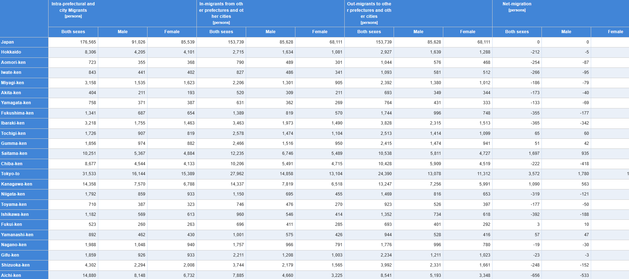

Figure 2: Number of Intra-prefectural Migrants, In-migrants from Other Prefectures and Out-migrants to Other Prefectures by Sex for Japan

Data on migration within Japan is shown in this table, with an emphasis on patterns of mobility between cities and within prefectures. It gives data on the number of people traveling both within and between prefectures and cities, as well as those relocating away from them. Data on net migration, which shows the difference between in- and out-migration for each prefecture and city, broken down by gender, is also included in the table. The migration data includes major cities and certain neighborhoods inside those cities, as well as other regions in Japan.

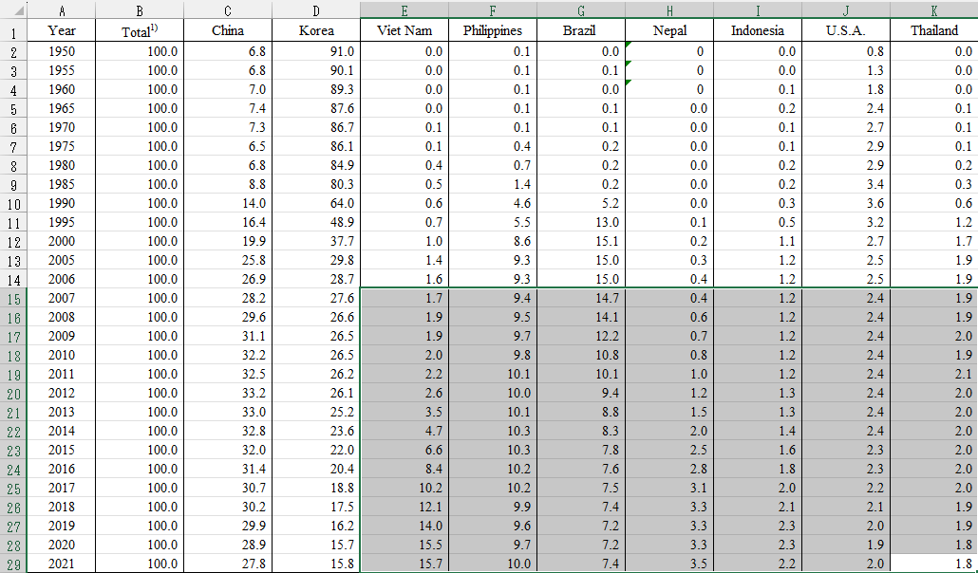

Figure 3: Proportion of immigrant into japan based on nationality

The table presents the percentage distribution of migrants from various nations or areas and provides a thorough analysis of migration trends into Japan from 1950 to 2021. There is a distinct variation in the composition of migrants over time, with significant changes in the main migration sources. The data indicates a gradual shift towards a more diversified terrain, with China emerging as a prominent source in recent years, after initially being dominated by migrants from Korea. Furthermore, the fact that nations like Vietnam, the Philippines, Brazil, Nepal, Indonesia, the United States of America, and Thailand are included highlights the growing diversity of immigrants that are boosting the population of Japan. These changes most likely reflect evolving social, political, and economic conditions in Japan as well as in the home countries of the migrants.

## Data Processing

### Table 1

Thorough data extraction and cleansing are necessary in order to evaluate migration trends in Japan in detail, with an emphasis on both inflows and outflows of foreign populations. The dataset offered includes comprehensive data on immigrant population inflows by country of origin between 2000 and 2022. Data cleaning first entails removing unnecessary rows and columns to leave just relevant variables (birthplace/nationality and total inflows by year, for example). In order to preserve the integrity of the dataset, it is also essential to address any incomplete or missing data points.

Following cleaning, attention turns to identifying and separating pertinent data, including inflows and outflows that are particular to Japan. To do this, the dataset must be filtered to obtain information on inflows and outflows into Japan while keeping information about other nations out. The retrieved dataset can then be further modified to give an unambiguous depiction of migration trends across time, revealing information about the inflow and outflow of foreign populations into Japan. Analysts can obtain important insights into Japan's migration patterns by carefully cleaning and extracting the data, which will help them comprehend how the country's demographic landscape has changed over the given period of time.

### Table 2

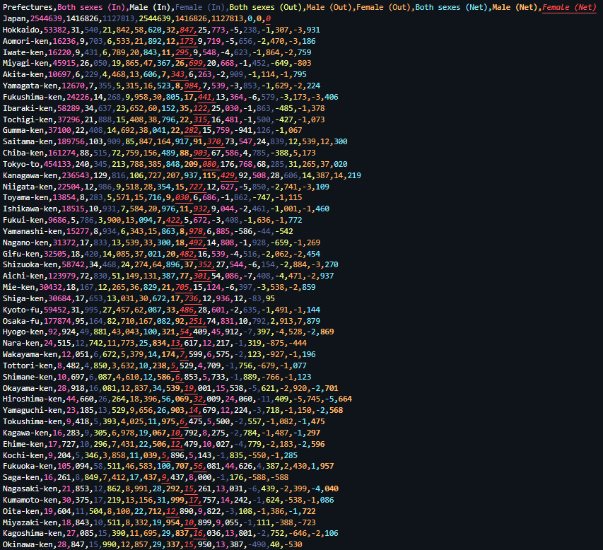

Figure 4: Inflows, Outflows and Net migration in japan based on prefectures

Carefully cleaning and formatting the data is the first step towards beginning an effective visualization of the migration data. This initial stage entails meticulously eliminating superfluous rows or columns and guaranteeing consistency in data structure throughout the complete dataset. Moreover, it involves determining net migration for every area by deducting out-migration from in-migration, providing crucial information about the dynamics of movement within every prefecture or city throughout the designated period. Data preparation for visualization is the next step after determining the net migration figures. Combining geographic data with net migration data is essential for the choropleth map. This integration makes it easier to depict migration patterns spatially and highlights areas with notable population shifts.

On the other hand, in order to examine gender differences in migration, gender-specific migration data must be removed and properly organized for the tornado chart. This phase makes it possible to identify any significant variations in the migration patterns of male and female populations in different locations. Gender dynamics and migration patterns among various Japanese prefectures and cities can be effectively communicated through the use of well-formatted, well-organized data in the resulting infographics.

### Table 3

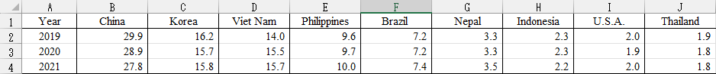

Figure 5: Proportion of immigrant to japan

It's crucial to concentrate on data cleaning to separate out the pertinent information in order to show the percentage of immigrants to Japan based on the provided data. We must filter the dataset appropriately since our goal is to examine immigration trends especially for the year 2019. In order to do this, data from 2019 must be extracted, leaving out data from previous years.

The dataset ought to include only data from 2019 after filtering. After that, we can figure out how many immigrants overall came to Japan in 2019 from other nations. The percentage of immigrants from each nation included in the dataset can be added together to achieve this.

Upon obtaining the aggregate percentage of immigrants to Japan in 2019, we can employ a bar chart or pie chart to illustrate the respective contributions of each nation to Japan's immigrant populace. This graphic will make it easy to comprehend how the immigrant population in Japan will be composed in 2019 and will draw attention to the nations that send the greatest number of immigrants to Japan.

# Requirements

## Must have requirement

* **Chart Title:** To provide users a clear idea of the underlying data, every chart needs to have a bolded title at the top. This title functions as a beacon of guidance, pointing visitors in the direction of the visualization's center and assisting them in quickly identifying the most important findings.
* **Axes and Scales:** To ensure accuracy and clarity in both horizontal and vertical directions, the axes should have scalable markers that are customized for the dataset. Users can easily move through the data and obtain a deeper knowledge of the trends and patterns shown in the chart by carefully calibrating the axes and scales.
* **Axes Labels:** To make the data representation easier to understand, the axes should have clear labels. As signposts, these labels direct users along the axes and offer vital context for understanding the data points. Users are able to rapidly position themselves within the chart and make well-informed conclusions when the axis labels are clearly defined.
* **Captions:** Every chart should have a caption that explains how to understand categorical data, along with legends and legend keys. The legend decodes the meaning of many colors, patterns, and symbols used in the chart, acting as a kind of decoder ring. Users may understand the relevance of each component in the visualization and derive valuable insights from the data by using the legend, which offers succinct and easy-to-understand explanations for each piece.
* **Color:** To facilitate clear discrimination, especially for users with visual impairments, strong contrast and consistent colors should be used across the chart's information. Color is essential for drawing users' attention to significant trends or anomalies in the data. No matter how visually impaired a user is, designers may guarantee that the visualization is still readable for them by using a color scheme that is harmonious and has enough contrast.
* **Summary/Explanation:** Each webpage should have a brief summary of the charts at the top that provides instructions on how to use and comprehend the visualization. This succinct description acts as a road map, giving users the background information and understanding they need to understand the intent behind and how to interpret the charts. Through succinct and lucid explanations, designers may facilitate user navigation.

## Optional requirement

* **Interactive Elements:** To enable more in-depth data study, provide tooltips, hover effects, or clickable features.
* **Responsive:** Make sure the visualization adjusts fluidly to various screen sizes and devices with responsive design.
* **Filtering:** Give consumers the ability to dynamically filter and sort data for individualized analysis.
* **Animation:** Use subdued animations to create more seamless transitions and increase user interaction.

# Visualization design

## Color

* Choropleth:



Figure 6: Choropleth color palette

Green and blue can be used as the color palette for the choropleth map to indicate the various levels of immigrant or emigrant populations in each prefecture. Shades of blue often denote higher levels of migration, whereas shades of green typically suggest lesser levels. With lighter shades signifying lower migration numbers and darker shades indicating larger migration numbers, this color scheme aids consumers in understanding the data intuitively. The map's use of green and blue tones helps to illustrate how immigrant and emigrant populations are distributed geographically throughout Japan's prefectures.

* Other chart:



Figure 7: Color palette for other chart

The color scheme of cornflower blue, lust, and pastel pea green can be utilized for other charts, like bar charts or line graphs.

* You can use cornflower blue to attract attention to key areas of the visualization by emphasizing specific categories or data elements.
* Since lust is a darker color, it can be used to create contrast or to symbolize different categories in the data.
* A softer, complementary color that balances the whole color scheme while preserving visibility and clarity is pastel pea green.

Users can readily grasp the information displayed in the chart thanks to this color combination's ability to communicate facts effectively while also having a pleasing visual appeal.

## Visualization elements

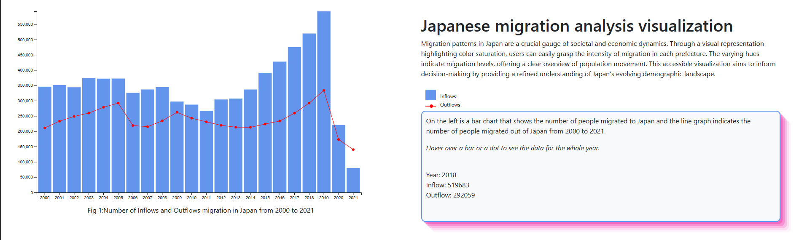

Figure 6: Inflows and Outflows of Japan from 2000 to 2021

* User can see the number of immigrant to Japan and emigrant from Japan over a 21-year period from 2000 to 2021
* This is also used as an introduction to our project.
* Color used: cornflower blue and red

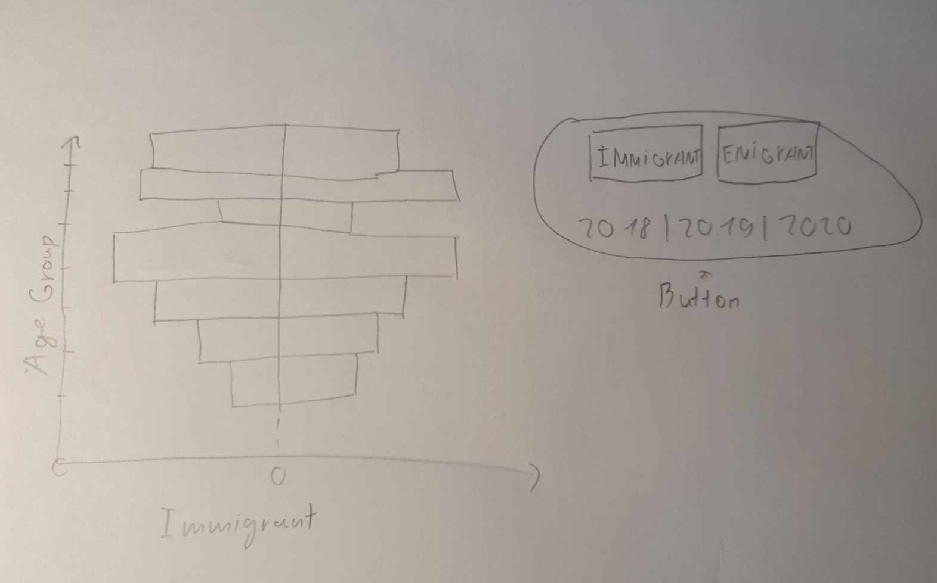Figure 7: Immigrant and emigrant in Japan based on age group and gender

The gender- and age-based migratory patterns in Japan are represented visually in the tornado chart. With interactive buttons, users can choose to view immigrant or emigrant data, as well as the preferred year (2018, 2019, or 2020). The graphic shows horizontal bars for each age group, with the length of the bar signifying the percentage of migrants in each gender and age group. This enables users to investigate the variations in migration trends throughout the chosen years between various age groups and genders.

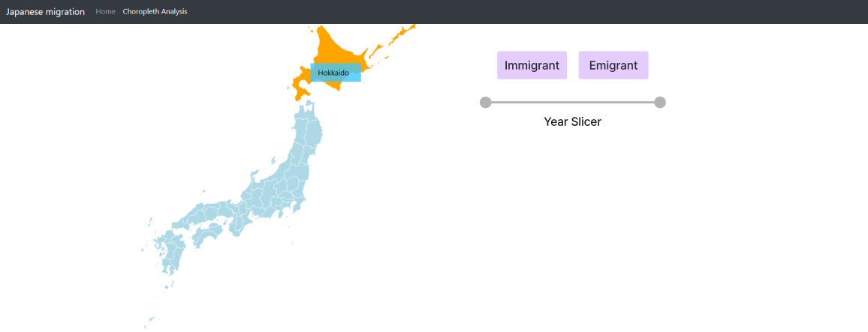

Figure 8: Choropleth map showing immigrant and emigrant in each prefecture

Depending on the chosen year, the choropleth map dynamically shows immigrant and emigrant data for every prefecture in Japan. Using interactive buttons, users can choose between seeing immigrant and emigrant data, and they can select the desired year from a slicer. The intensity of migration is used to tint each prefecture; bigger numbers of immigrants or emigrants are indicated by darker tones. Users can investigate migration trends over time throughout various Japanese prefectures using this interactive graphic, which offers insightful information on regional migration patterns.

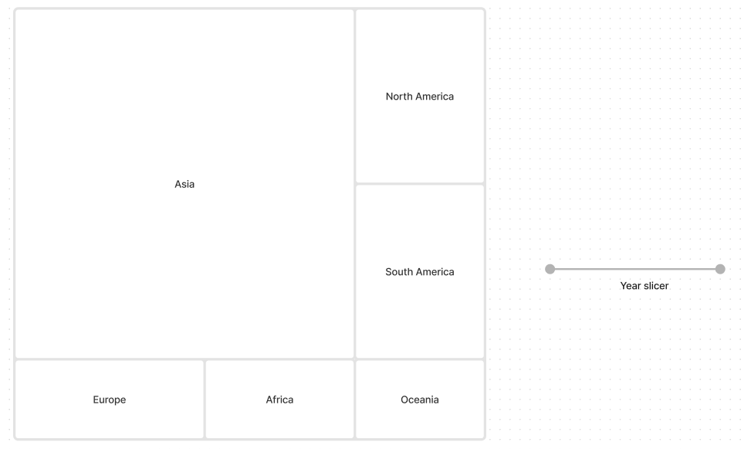

Figure 9: Origin of immigrants

The percentage of immigrants to Japan by continent of origin is depicted in the tree map. A continent is represented by each rectangle in the tree map, and the size of the rectangle corresponds to the number of immigrants from that continent. With the help of the slicer, users may interactively investigate immigration patterns by continent and learn how immigration from various regions of the world has affected Japan's population over time. This chart helps explain the geographic distribution of immigrants to Japan by offering a thorough summary of immigration trends broken down by continent.

The percentage of Japanese emigrants by continent of destination is depicted in the tree map. The sizes of the rectangles in the tree map correspond to the number of emigrants to each continent, and each rectangle represents a continent. With the help of the slicer, users can interactively investigate emigration patterns by continent and see how, over time, emigration to various regions of the world has affected Japan's population. Understanding the global distribution of Japanese emigrants is made easier by this image, which offers a thorough summary of emigration trends broken down by continent.

# Validation

# Conclusion

# Reference